Touch the Source of Life
Because from him; life springs. (Prov 4,23)

Live!!

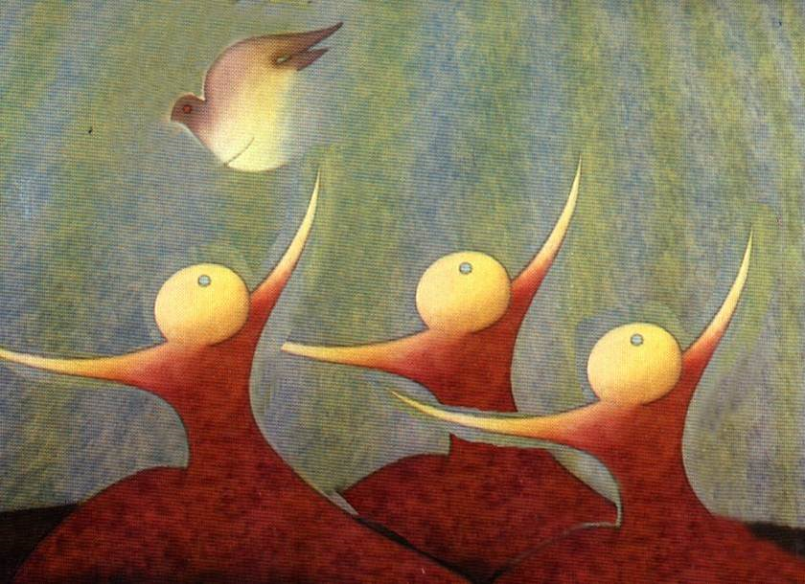

Recollection Day January 2024.
Mari Carmen Ferrero hcsa
They say that our best teacher is life, and it is true. Life, like in the story of Thumbelina, leaves us small signs that show us the path to follow, we just need to discover them and learn from what Life leaves at our side.
We have just celebrated the "great sign", the Presence of a God who wants to be a child and who leaves us some clues: manger, child, the outskirts, shepherds...reminding us again and again, the wonderful dance of descent, the dance of the incarnation.
This “dance”, like all dances, has many steps, many turns, and some other movement, which depending on how we do it, produces vertigo and disorients us, turning our lives “upside down”.
In this attempt to live ourselves as women in movement, open to the passage of God through our lives and willing to live ourselves as women standing, two women will accompany us: The hemorrhagic woman and the bent woman.
They will give us “signs” that may put our lives in the open, but perhaps we will also discover with them the joy of finding and touching the Source of Life: Jesus of Nazareth.
With them, we are going to enter the realm of divinity, where God Father-Mother calls us “Beloved Daughters” and allows us to taste and savor the Source of Life that sustains our own life and the life that surrounds us. With them, we are going to discover where we lose our lives, and what attitudes keep us “bent over”, unable to look straight ahead.

Jesus came to wake us up and since then we are waking up despite so much sleep on our part.
Javier Melloni

Together with the bent woman (Lk 13:10-17) and the woman with blood loss (Mk 5:25-34) we are going to begin a process of shaking off our numbness, on many occasions, caused by attitudes that live installed in us for a long time and they prevent us from living as women on our feet (our friends were 12 and 18 years old)

A call to straighten up: “She was bent over for 18 years and couldn't straighten up.

A call that is accompanied by a profound invitation to inhabit the Center, because only from the depths can we perceive the desire to live ourselves fully. Only from the Center will we be able to open ourselves to trust and hold tightly to Him, who is the healer of dignities and curvatures.
Living as standing women does not depend on our wills and efforts, but on our ability to welcome the gift and glimpse the Source of Gratuity that inhabits and sustains us.
And from the Original Source of Gratuity, desire is awakened and the call to live straight is heard.
Let the bent woman take you by the hand and tell her own story (which may also be yours) and give you some of the keys that helped her straighten up.
- Let yourself be looked at by Jesus : “When Jesus SEE HER, he called her.”

The story says that it was Saturday and Jesus was teaching in the synagogue. With these data, it is easy to imagine that there would be a large number of people...And Jesus SEES her in the middle of the crowd and that healing look allows the woman to feel liberated and loved. There are many people “keeping the law,” but only Jesus sees the woman, and that look heals and restores her.
Letting ourselves be looked at by Jesus involves placing ourselves before him with all our truth, with those “curvatures” that keep us prostrate without being able to look straight ahead. Allowing ourselves to be looked at by Jesus means giving a name to those realities in our lives that little by little are “curling” us and we are only able to see “our navel”, and everything that has to do with “my interests”. Sometimes I wonder how many times have I complained or do I complain about the unmet need of others? And the answer I give myself is that rarely, or perhaps not at all.
And today I ask myself the question again and I invite you to ask it to yourself: Does anyone complain because my sister community needs more tenderness, more attention, more dedication? …Do we ever complain because the reality of our world is increasingly painful, more in need of love, tenderness, hospitality…and so much pain weighs on my soul?
For our “complaint” to spring from love, commitment, dedication and knowing that we are all one Unity, it can only spring from a “place”: the Center, the depth of the soul, that space that is known to be inhabited by the One who SEES. and sees us.
Sharing all these concerns today at breakfast with the sister of the community, some clues inherited from our Founders and First Sisters have emerged, and which are a permanent call, to live as “straightened” women, looking up from our navel and uncurling ourselves:
- María Rafols “complains” to the French general because the poor people in the Hospital do not have food.
- She “complains” to the Besieged because the mistresses do not receive their salary.
- Juan Bonal, touches the reality of poverty in the Hospital, sees the pain and misery of the sick, and sets off, walking along paths and praying for and for others.
- Many of the First Sisters die of hunger because they share their food with the poorest...and in our historical texts, not a single complaint appears because they have little.
And all of them, in the month of January 1805, unbend themselves to put themselves at the service of the poor sick, with the certainty that it is Jesus Christ whom they serve: “You did it to me.”
- Let yourself be touched by Jesus: “Jesus laid his hands on her…”.

The text, as we have seen, says that the woman was bent over and could not straighten up, which indicates that this woman was shrunken. It is not difficult to imagine that Jesus would have to bend down in order to touch her and lay his hands on her.
How hard it is for us to bend! (like the head of the synagogue who is outraged because Jesus heals on Saturday) but we continue to “comply” because it is the right thing to do…
Love has nothing to do with “you owe” or “you have”. Love is not a “must”, it is not a “I have to”, it is the natural expression of who we ARE. From “height” it is impossible TO TOUCH life, to touch life, it is essential to “bend down”, get down, put ourselves in the other's place.
Jesus touched the woman, even if he had to “lower himself” to do so. Touching is a sign of affection, of tenderness; It is a sign of complicity, and of saying with gestures, here I am, count on me!; It is a gesture of endearing love and healing.
But it is difficult for us to caress ourselves, to express our capacity for tenderness; It is as if we hide our feminine wealth; that gift with which we are enriched and that we usually express outside of community settings, but among ourselves, we do not usually lavish ourselves with gestures of tenderness, much less touch the vulnerability of the other.
- Allow yourself to be touched by Jesus to lift yourself up: “Immediately he straightened up”

Lift up so many realities that remain fallen, bent, lift up, being messengers and bearers of hope inside and outside our communities, in our social context, in the places and with the people with whom we share and live the task from the Mission, of being expression of the Goodness and Mercy of God.
Jesus RAISED the woman, restored her dignity, set her on her feet. And the woman opens up to Jesus when she feels touched.
And his response could not be more coherent: “Immediately he stood up and gave glory to God.”
An encounter with the God of Jesus that does not lead us to COME CLOSER, TOUCH life and RAISE life, is not an encounter, there is no experience, we have simply “fulfilled” the schedule, but it has not transformed us.
It is true that we cannot live this as if on the run; it is a process, a desire to live from the experience of God that Jesus of Nazareth lived, a process that requires each of us to know how to STAY, without seeking anything or anything. trying to change anything... the woman in our story does not “do” anything, and does not “say anything”, she only REMAINS in the PRESENCE of Him, who is working the transformation in us.
We do not “do” prayer, WE ARE prayer. Praying is a way of BEING, of realizing that God IS and WE ARE in Him.
A process that necessarily involves experiencing HUMILITY, recognizing our truths and also everything that is “false” in our lives. Humility that cannot but be accompanied by the ACCEPTANCE of our own truth and complete TRUST in the Goodness of God, who continues to sustain our lives and guide our own history of salvation.

A call to discover where you are
life escapes us. “There was a woman who was wearing
twelve years suffering from hemorrhages”
- Call to live fully
And another woman, invited to touch Jesus, will lead us in this process of Following Jesus.
With the woman who suffers blood loss, we begin the journey back home, to the depths, to the place where the source of our losses “dryes up.” She will show us the path of following Jesus, the path of true discipleship, the Christological root of our calling and vocation.
For us, Sisters of Charity of Saint Anne, this dimension touches the roots of our spirituality.
“Our spirituality, from the beginning, has been centered on the person of Christ.
For our first Sisters He was the starting point of their vocation, the path to follow in their dedication and the goal to achieve in the joyful exercise of charity.
Like them, you are called to be a response to this love of God. Remain in intimate union with Christ, discover it in the people you serve and be a witness to his love.” OV77
Together with the woman who is losing her life (blood was the symbol of life in the Jewish mentality), we are going to discover the keys to this following of Jesus, and the calls to respond to the Love that inhabits us.
A call and a desire that puts this woman in an itinerant attitude. A movement and itinerancy, which is not without difficulties, (he had spent his fortune) because all movement and itinerancy entails risks.
But we also find in her a creative woman capable of making decisions, discerning and always putting herself in an attitude of departure, looking for alternatives to the intuitions she perceives in her life:
- Try “business as usual,” “it's always been done this way.” And he goes to what is established, that is, he goes to the doctors and invests his fortune in the attempt to heal himself.
And she discovers that business as usual is not the solution and she becomes a searching woman, considering other alternatives: turning to Jesus.
“Having heard about Jesus, he turns to him”
- From a free attitude, without victimhood, without playing the martyr for her illness and what happens to her, she decides to stand behind Jesus to touch his cloak.
- And breaking all the laws, touching Jesus, he begins to live. “Touch the cloak” means to adhere to Jesus. And this adhesion takes you to the Source of Health and Life.
- Knowing that Jesus is looking at her, the woman reacts with “fear and awe”
Fear and awe that accompanies every manifestation of the divine. An awe that opens us to amazement, to the novelty of an encounter, that reveals to us the face of God the Father-Mother, who becomes a gaze and encounter in Jesus of Nazareth, who seeks us with his gaze and this gaze transforms our lives. and awakens in us an attitude of adoration . “And he fell at his feet”, a gesture of adoration before the divine.
A MOMENT TO STOP

With the woman who suffered loss, at this moment in your life, you can ask yourself about your experience of encountering Jesus.
Does it produce in you an awe that leads you to “touch the mantle,” that is, to adhere to it with all your strength, with your entire being? Does your confidence lead you to let yourself be looked at by him and recognize yourself as a woman transformed by his presence?

This woman appears to us as a standing woman, a woman who is aware that she is losing her life, and seeks solutions to respond to the deep longing for life that she feels inhabits her. She seeks to live fully and this desire sets her in motion:
- She decides to stand up to her “illness”, recognizes that her life is slipping away and refuses to live resigned to her fragility… and makes decisions.
- He is able to reflect and draw up an itinerary. She does not settle into routine and superficiality: “It was said that just by touching her cloak she would be healthy.”
- She dares to recognize her own truth and tells Jesus “her own truth,” establishing a dialogue with Jesus, which is born of trust and security, and which makes her feel not only healed, but saved.
- …And from the experience of salvation, emerges the profound experience of recognizing oneself as a DAUGHTER. Jesus introduces her into the realm of closeness and familiarity with God, leads her to the place of her true identity, the place where she can taste the Trust that is, the Peace that inhabits her and the healing that allows her to glimpse and taste the Life, and a Life in fullness.

…The last gift from our friends.

The two women have a gift for each of us. There is a word that unites them and that today they want to leave in our hands: IMMEDIATELY.
The bent woman, the text tells us: she straightened herself instantly, at the moment ...
The woman with losses experienced in her own body that: the source of her hemorrhages immediately dried up.
This immediacy is not the result of my will, nor of our purposes. If we observe the two texts of Mark and Luke, we can see clearly that neither of the two women “does” anything, they only approach, touch, trust and They let Jesus act in them...and the response cannot be any other: IMMEDIATELY their lives are transformed. The true encounter is always transformative, because it is not us who transform, it is God who transforms us...and God, it is IMMEDIATE.
Perhaps, our lives are called to tell ourselves the truth, recognize our curvatures and the places where life escapes us and allow Jesus to truly be the center of our lives, to glimpse the passage of God and recognize the gift of his presence and enjoy the loving and tender touch of the Mystery. Feeling caressed and looked upon by Jesus of Nazareth, a mirror of what each of us and each of the human beings with whom we share the sphere of familiarity with God really are.

WE PRAY AND SHARE

We sat next to the two women to begin a dialogue with a taste of sisterhood. I become aware of those areas of my life that need to be "straightened", asking for light to give names to those spaces, places, attitudes... where I think my life is slipping away.
I do not look at these realities of my life from guilt, shame or hopelessness, I look at them and embrace them as an opportunity to feel the hand of Jesus on me, to feel his gaze and recognize myself as fragility, but inhabited fragility.
Mc 5, 24-34: What attitudes of this woman are for me today a call to live as a standing woman?

Luke 13:10-17 : “She was bent over and could not straighten herself”
What keeps me hunched over and doesn't allow me to look straight ahead: at myself, at others, at God?
What do I need to free myself from?
Woman, you are free from… You can list them…
And if you share it in a community, you will surely experience liberation...and feel part of the COMMUNITY, which we are all building together.

SONG: Twelve years

